AUTOMAPPER

- Add nuget package in Application Module:
  - Automapper.Extensions.Microsoft.DependencyInjection
- Create RestaurantsProfile.cs under Application/Restaurants/Dtos
  - Public class
  - Inherit Profile
  - Create CreateMap method (Others will map automatically but address and dish are not)
  - Invoke ForMember method to include address and dishes
- Create DishesProfile.cs under Application/Dishes/Dtos
  - Public class
  - Inherit Profile
  - Create CreateMap method
- Edit RestaurantsService.cs to change the manual dto we do before
  - Inject the IMapper interface and named it mapper
  - Change the necessary part
- Edit our DependencyInjection container by editing ServiceCollectionExtension.cs in Application Module not in the infrastructure module
  - Create AddAutoMapper()
- Remove manual Dtos file in RestaurantsDto and DishDto which is public static part
- Run the web api and test (check whether the result same with Returning Dtos part)

STEP BY STEP TUTORIAL

- Add nuget package in Application Module:
  - Automapper.Extensions.Microsoft.DependencyInjection
- Create RestaurantsProfile.cs under Application/Restaurants/Dtos
  - Public class (create constructors)
  - Inherit Profile
  - Create CreateMap method (Others will map automatically but address and dish are not)
  - Invoke ForMember method to include address and dishes
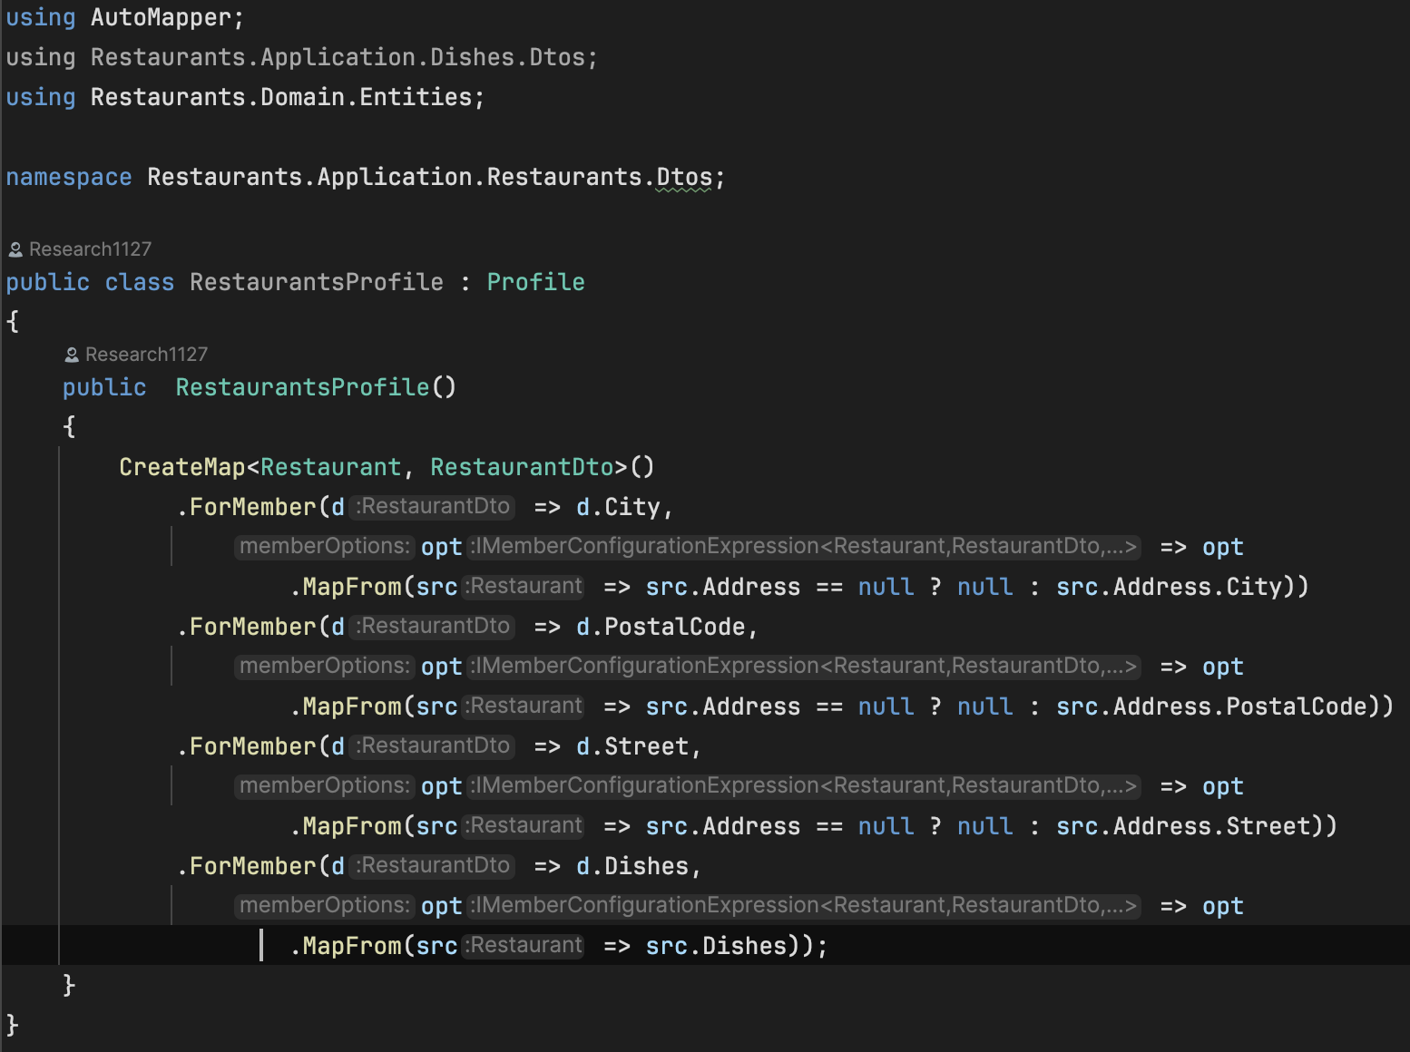

- Create DishesProfile.cs under Application/Dishes/Dtos
  - Public class
  - Inherit Profile
  - Create CreateMap method
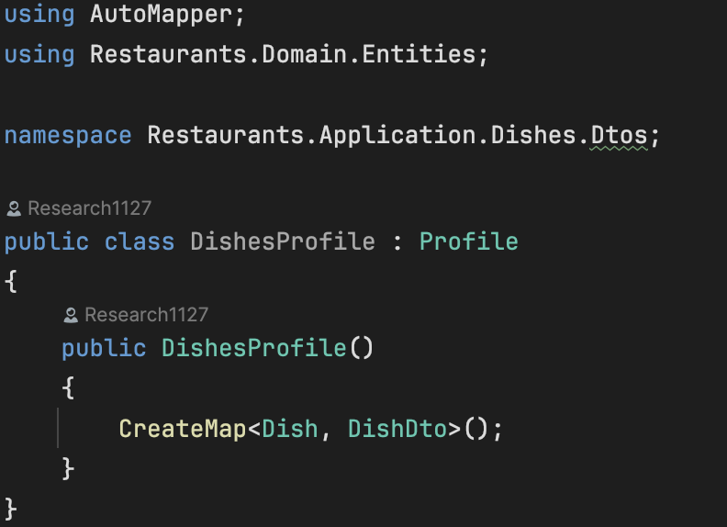

- Edit RestaurantsService.cs to change the manual dto we do before
  - Inject the IMapper interface and named it mapper
  - Change the necessary part
  - Edit restaurantsDtos and restaurantDtos variable
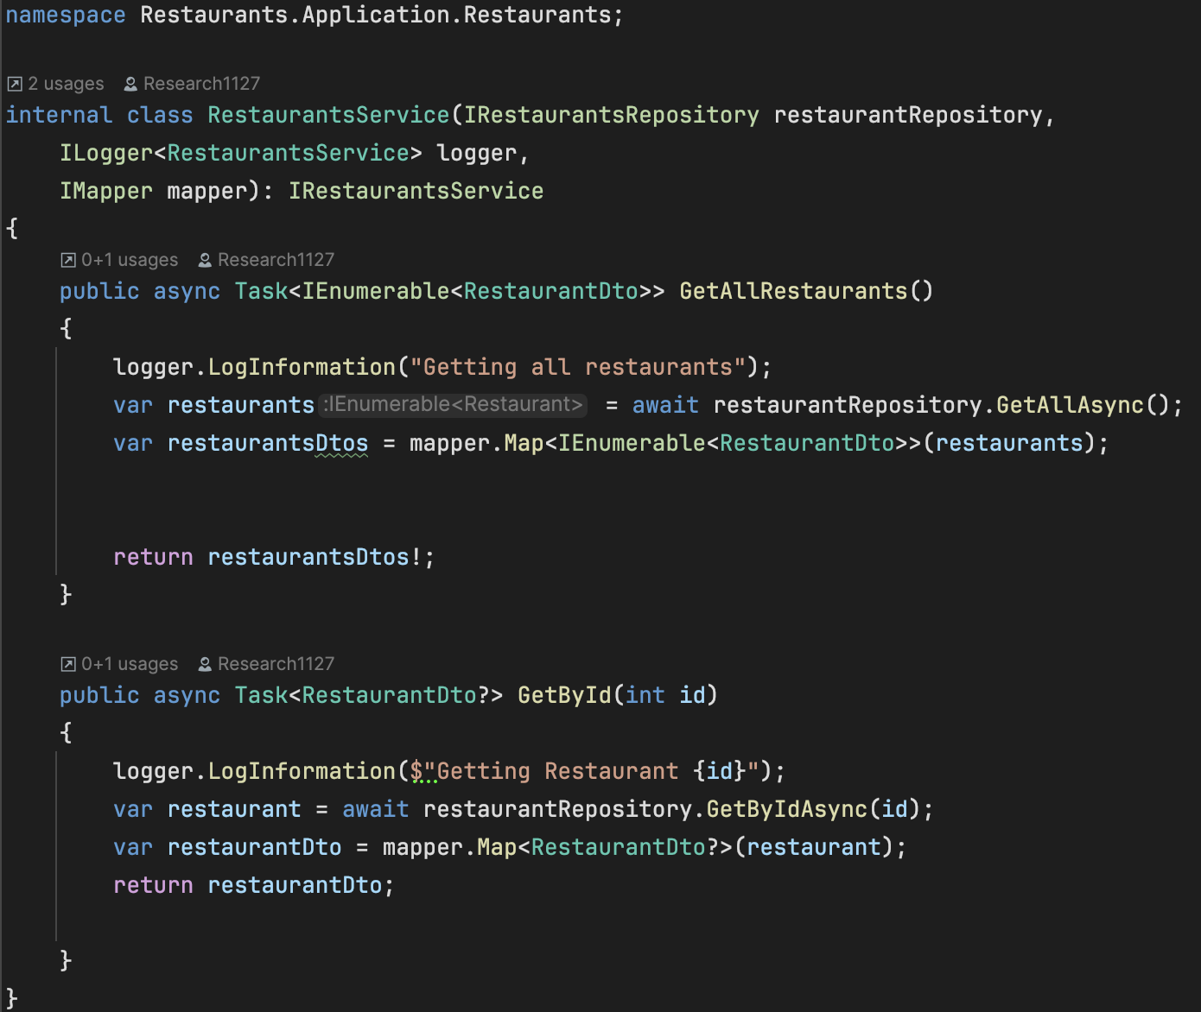
- Edit our DependencyInjection container by editing ServiceCollectionExtension.cs in Application Module not in the infrastructure module
  - Create new services AddAutoMapper()
- Remove manual Dtos file in RestaurantsDto and DishDto which is public static part
- Run the web api and test (check whether the result same with Returning Dtos part)

